**ANGULAR WEEK-3 ASSIGNMENT**

**1.** Develop a Angular Project that show cases One way and two way data binding (Property binding and Event Binding).

**app.component.html**

<h1><b>.......PROPERTY BINDING........</b></h1>

<h3>WELCOME...<span [innerHTML]='firstname'></span></h3>

<h1><b>.......EVENT BINDING...........</b></h1>

<button (click)="onClick()">Click me</button>

<h1><b>........TWO WAY BINDING......</b></h1>

Enter the value  : <input [(ngModel)] ='data1'>

                <br>

                 Entered value : Hi  {{data1}}

**app.component.ts**

import { Component } from '@angular/core';

@Component({

  selector: 'app-root',

  templateUrl: './app.component.html',

  styleUrls: ['./app.component.css']

})

export class AppComponent {

  firstname: string = "SAI LAKSHMI";

  onClick(): void {

    console.log('you clicked me!!');

    let data1: String='';

}

}

**app.component.ts**

import { BrowserModule } from '@angular/platform-browser';

import { NgModule } from '@angular/core';

import { AppRoutingModule } from './app-routing.module';

import { AppComponent } from './app.component';

import { FormsModule } from '@angular/forms';

@NgModule({

  declarations: [

    AppComponent

  ],

  imports: [

    BrowserModule,

    AppRoutingModule,

    FormsModule

  ],

  providers: [],

  bootstrap: [AppComponent]

})

export class AppModule { }

**OUTPUT:** 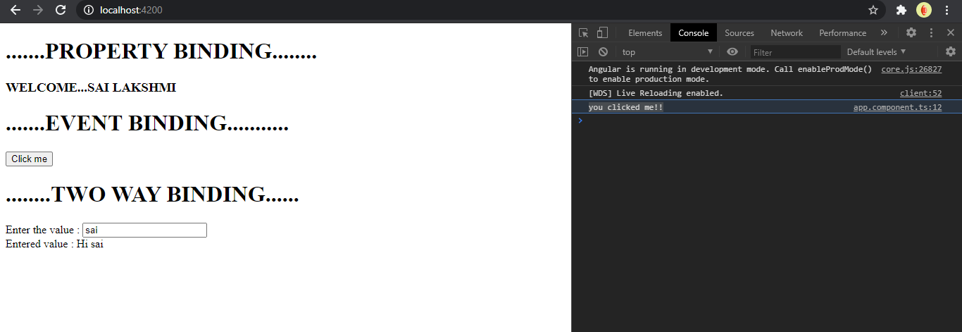

2. Develop a Angular Project that show cases the following Event binding :- a) Text Box’s key entry c) Text Box Key Enter d) Text Area Keyup +Shift +A b) Button on Click

**app.component.html**

<!-- Text Box's key entry -->

<input (keyup)="onkey($event)"/>

                <br>

                <p>This is box key entry value is {{name}}</p>

            <!-- Text Box key enter -->

               <input #box (keyup.enter)="onenter(box.value)"/>

               <br>

               <p>This is box key enter value is {{value}}</p>

            <!-- Text area keyup + shift + A -->

               <input #box1 (keydown.Shift.A)="onenter1(box1.value)"/>

               <br>

               <p>This is box keyup+shift+a is {{val}}</p>

                 <!-- Button on click -->

                <button (click)="Hit()">Submit</button>

**app.component.ts**

import { Component } from '@angular/core';

@Component({

  selector: 'app-root',

  templateUrl: './app.component.html',

  styleUrls: ['./app.component.css']

})

export class AppComponent {

  title = 'angularAssignment1';

  name:any='';

  onkey(event:any){

    this.name=event.target.value;

  }

  value:any='';

  onenter(value:string){

    this.value=value;

  }

  val:any='';

  onenter1(key:string){

    this.val=key;

  }

  User:any;

  Hit(){

    this.User='This is button click event';

  }

}

3. Develop a Angular project that uses template [reference](https://www.rightstroketraining.com/mod/lesson/view.php?id=20) variable for text box, text area and select drop down control

app.component.html

<div class="container">

    <div>

        <select #select [(ngModel)]="selectedcity" (change)="log(select.value)">

            <option *ngFor="let city of cities" [value]="city.id">{{city.name}}</option>

        </select>

    </div>

    <br>

    <div>

        <button (click)="Str=''">Clear</button>

    </div>

    {{Str}}

</div>

app.component.ts

import { stringify } from '@angular/compiler/src/util';

import { Component } from '@angular/core';

@Component({

  selector: 'app-root',

  templateUrl: './app.component.html',

  styleUrls: ['./app.component.css']

})

export class AppComponent {

  title = 'angularAssignment1';

  selectedcity:number=0;

  public cities:any=[

    {

      id:1,

      name:'Chennai',

      state:'TN'

    },

    {

      id:2,

      name:'Hyderabad',

      state:'TS'

    },

    {

      id:3,

      name:'Vizag',

      state:'AP'

|  |
| --- |
|  |
|  |  |
|  |  |
|  |  |

**4.** Develop a Angular Project with one child control. And pass data from parent control (ex app.component.ts) to the child data via property binding

app.component.ts

import { BrowserModule } from '@angular/platform-browser';

import { NgModule } from '@angular/core';

import { FormsModule } from '@angular/forms';

import { AppRoutingModule } from './app-routing.module';

import { AppComponent } from './app.component';

import { ChildComponent } from './child/child.component';

@NgModule({

  declarations: [

    AppComponent,

    ChildComponent

  ],

  imports: [

    BrowserModule,

    AppRoutingModule,

    FormsModule

  ],

  providers: [],

  bootstrap: [AppComponent]

})

export class AppModule { }

app.component.html

<app-child *ngFor="let user of Users" [value1]="user.fname"></app-child>

child.component.html

<p>The selected city is {{value1}}</p>

child.component.ts

import { Component, Input, OnInit} from '@angular/core';

@Component({

  selector: 'app-child',

  templateUrl: './child.component.html',

  styleUrls: ['./child.component.css']

})

export class ChildComponent implements OnInit {

  constructor() { }

  @Input()

  public value1:String;

  ngOnInit(): void {

  }

}

app.module.ts

import { BrowserModule } from '@angular/platform-browser';

import { NgModule } from '@angular/core';

import { FormsModule } from '@angular/forms';

import { AppRoutingModule } from './app-routing.module';

import { AppComponent } from './app.component';

import { ChildComponent } from './child/child.component';

@NgModule({

  declarations: [

    AppComponent,

    ChildComponent

  ],

  imports: [

    BrowserModule,

    AppRoutingModule,

    FormsModule

  ],

  providers: [],

  bootstrap: [AppComponent]

})

export class AppModule { }

**5.** Develop a Angular Project that displays a list of Products details (id, name,description,cost) in a grid format. The solution should be able to display unique identifier for each record, and able to show even and odd record with efficient data update technique.

app.component.html

<div class="container mt-5">

    <table class="table">

        <tr>

            <th>ID</th>

            <th>Product</th>

            <th>Description</th>

            <th>Cost</th>

            <th>Even</th>

            <th>Odd</th>

        </tr>

        <tr *ngFor="let person of persons;even as e;odd as o">

            <td>{{person.Id}}</td>

            <td>{{person.Product}}</td>

            <td>{{person.Description}}</td>

            <td>{{person.Cost}}</td>

            <td>{{e}}</td>

            <td>{{o}}</td>

        </tr>

    </table>

<div class="row">

  <div class="col">

    <input type="number" class="form-control" placeholder="Id" [(ngModel)]="Id">

  </div>

  <div class="col">

    <input type="text" class="form-control" placeholder="Product Name" [(ngModel)]="Product">

  </div>

  <div class="col">

    <input type="text" class="form-control" placeholder="Description" [(ngModel)]="Description">

  </div>

  <div class="col">

    <input type="text" class="form-control" placeholder="Cost" [(ngModel)]="Cost">

  </div>

  <div class="col">

    <button class="btn btn-primary btn-block" (click)="add(Id,Product,Description,Cost)">Add</button>

  </div>

</div>

</div>

app.component.ts

import { Component} from '@angular/core';

@Component({

  selector: 'app-root',

  templateUrl: './app.component.html',

  styleUrls: ['./app.component.css']

})

export class AppComponent

{

  title = 'angularAssignment1';

  persons = [

  ];

  Id:number;

  Product: String;

  Description:String;

  Cost:String;

  add(Id,Product,Description,Cost){

    this.persons.push({

      "Id":Id,

      "Product": Product,

      "Description":Description,

      "Cost":Cost

    });

    // resetting the input field

    this.Id = undefined;

    this.Product = "";

    this.Description="";

    this.Cost="";

  }

}

6. Develop a Angular Project that displays a list of countries(ex India.Singapore,USA,UK) in a drop down, based on the selected country we need to display specific contents to the user. If India is selected, the page should display a section asking the user to enter the name and aadhaar number, if US is selected the page should display a section asking the user to enter SSN and Passport number, in case of UK, the user should see the section to enter only the password.

<div class="container p-20">

    <h3>Please select the country:</h3>

    <select  [(ngModel)]="k">

      <option *ngFor="let cnt of countries" [value]="cnt.Id">{{cnt.Country}}</option>

    </select>

  </div>

  <br>

  <div class="container">

    <div [ngSwitch]="k">

      <div *ngSwitchCase="1">

        <div class="container">

          <div>

            <label>Enter the name:</label>

            <input type="text" class="form-control" placeholder="Username">

          </div>

          <div>

            <label>Enter the Aadhar number:</label>

            <input type="text" class="form-control" placeholder="Aadhar">

          </div>

        </div>

      </div>

      <div *ngSwitchCase="2">

        <div class="container">

          <div>

            <label>Enter the SSN number:</label>

            <input type="number" class="form-control" placeholder="SSN number">

          </div>

          <div>

            <label>Enter the passport number:</label>

            <input type="number" class="form-control" placeholder="Passprt number">

          </div>

        </div>

      </div>

      <div *ngSwitchCase="3">

        <div class="container">

          <div>

            <label>Enter the Password:</label>

            <input type="password" class="form-control" placeholder="Password">

          </div>

      </div>

  </div>

  </div>

app.component.ts

import { Component} from '@angular/core';

@Component({

  selector: 'app-root',

  templateUrl: './app.component.html',

  styleUrls: ['./app.component.css']

})

export class AppComponent

{

  title = 'angularAssignment1';

  k:number=0

  countries=[

    {Id:1,Country:"India"},

    {Id:2,Country:"AUSTRALIA"},

    {Id:3,Country:"JAPAN"},

]

}